**Assignment Activity Unit 7**

Kelechi Nwa-uwa

University of the People

CS 1111-01

Dr. Ana Belen Sanchez-Prieto

Wednesday, 22nd October, 2025

**Part 1: Algorithm Development**

Step 1. INPUT to monthly_income

Step 2. INPUT to fixed_expenses

Step 3. COMPUTE variable_expense_total ←0

Step 4. REPEAT STEPS 5 THROUGH 7 (Start Loop)

Step 5. INPUT variable_expense

Step 6. IF variable_expense > 0

THEN COMPUTE variable_expense_total ← variable_expense + variable_expense_total

Step 7. COMPUTE total_expense ← fixed_expenses + variable_expense_total

Step 8. COMPUTE remaining_budget ← monthly_income - total_expense

Step 9. PRINT remaining_budget

Step 10. STOP

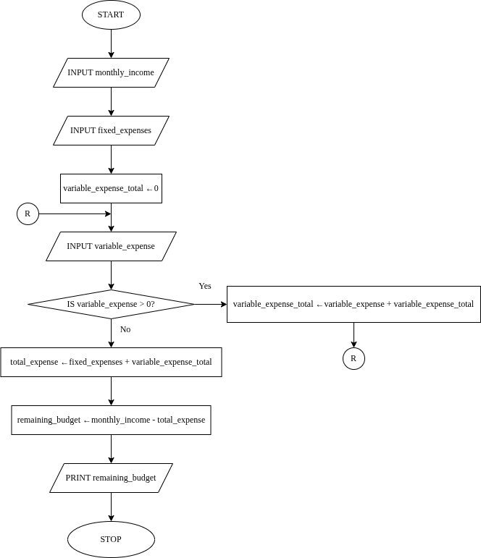

**Part 2: Debugging Techniques; Logical Error Resolution**

Assume a logical error occurs where the algorithm occasionally miscalculates the remaining budget, resulting in incorrect values. Describe how you would use debugging techniques and tools to identify and rectify this logical error.

The first thing I would do is isolate the error (Nduta, 2023). In this case, it may be that my *total_expense* variable is not correctly computed. It may also be that I am not subtracting the *total_expense* from the *monthly_income*.

Once I have identified where the error is coming from, I will try to reproduce it using print statements and various input scenarios. This would involve passing in different values. The goal of this is to discover which inputs result in a miscalculation and to identify what they have in common. This will let me know why the algorithm only miscalculates occasionally, rather than all the time.

Having a clearer view of the error, I can determine what the solution will be. This may be changing the line of code that calculates the *total_expense* variable, or something else. After fixing the error, I will test to ensure that the solution was the right fit.**References**

Nduta, A. (2023, January 25). *What is debugging? A simple guide for beginners*. CareerFoundry. <https://careerfoundry.com/en/blog/web-development/what-is-debugging/>